**Task3**

**High-Performance Time Series Transformation with NumPy & Pandas**

**Problem Statement:**

This task focuses on high-performance computations on large scale based time series data like above 1 million rows, both using Numpy and Pandas. The goal is to check and evaluate how their trade-offs in speed and memory changes with respect to Numpy and Pandas. The common transformations to be used are:

* Rolling statistics (mean, variance, covariance)
* Exponentially Weighted Moving Average (EWMA)
* FFT-based bandpass filtering

**Objectives:**

* Implement time series operation with both Numpy and pandas.
* Comparing performance (speed and memory)
* Generating synthetic data (more than 1 million rows with 3 sensor data).

### **Dataset Description**

Synthetic data with:

* 1,000,000 rows
* 3 sensors (sensor_1, sensor_2, sensor_3)
* Timestamp from 2022-01-01 onwards (1 second frequency)

### **Auto-Selection Logic**

If performance or memory becomes critical, a utility function can automatically select:

* NumPy for smaller memory or parallel computations.
* pandas for faster computing and flexibility with labels

**Performance benchmark:**

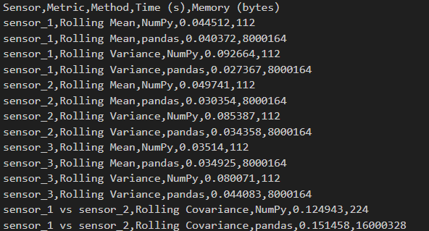

**Visualization:**

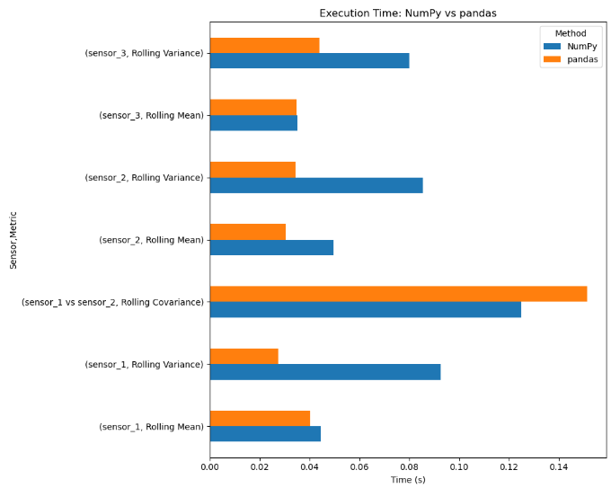

**Memory usage**:

* NumPy = small memory (just the numbers)
* pandas = slightly more memory (numbers + labels + structure)

FFT (Fast Fourier Transform) helps clean up signals (remove noise) and understand frequency patterns.  
With smart benchmarking, the program can automatically pick whichever method (ie. NumPy or pandas) is faster for the current data.

**Key learning and conclusion:**

* Pandas is easier to use, especially for time series (date-wise) data. It has functions like .rolling() that sometimes works faster than Numpy.
* NumPy is faster sometimes and uses less memory because it works with simple number arrays and avoids extra stuff like labels or indexes.
* Sometimes NumPy wins (especially with simple things like mean or variance).
* Sometimes pandas is faster than Numpy.
* It depends on the data size, and the type of maths.